# Using R to model daily returns in ARIMA.

Table of Contents

List of Figures 3

List of Tables 3

Contribution 4

Executive Summary 5

Introduction 6

Source of Data 6

1. Data Cleaning 7

Exploratory Data Analysis (EDA) 8

Finding series Kernel density and Box Plot: 9

2. Starting Box-Jenkins modelling technique: 10

2.1 Stationarity check using scatter plot. 10

2.1 Conclusion 10

2.2 Stationarity Check by Augmented Dickey–Fuller Test 10

2.2 Conclusion 10

Part A: 11

2.3.A. Finding AR and MA component: Visual Method 11

2.3.A. Conclusion 11

2.4.A. Fitting model 11

2.5.A Method 1: Running Diagnostic checks on residuals: Visual Method 12

2.5.A Method 1: Result and Conclusion 12

2.5.A Method 2 Running Diagnostic checks on residuals: Ljung–Box Test 13

Part B: 14

2.3.B. Finding AR and MA component: Software recommendation (Auto ARIMA) 14

2.4.B. Fitting the model: Attempt 2 -> (2,0,3) 14

2.5.B Method 1: Running Diagnostic checks on residuals: Visual Method?? 14

2.5.B Method 1: Result and Conclusion 14

2.5.B Method 2 Running Diagnostic checks on residuals: Ljung–Box Test 15

2.5.1 Adding fitted values of model_1 and model_2 to data frame 15

2.6 Making Predictions from test set. 16

3.A Plotting Model 1: ARIMA (4,0,0) 17

3.B Plotting Model 2: ARIMA (2,0,3) 18

3. (A, B) Plot: Model 1 vs Model 2 19

3. Finding Model Accuracy 20

4.1. MAE 20

4.1 Results: Accuracy by MAPE 20

4.2 Results: Accuracy by MASE 20

5 Conclusion 21

# List of Figures

Figure 1: Kernel Density and Box plot of Returns and Closing Price 9

Figure 2: Scatterplot of Close price. 10

Figure 3: Scatterplot of Close price. 10

Figure 4: ACF and PACF plots of Close price and Returns. 11

Figure 5: Model 1 ARIMA (4,0,0) residuals diagnostic checks. 12

Figure 6:Model 2 ARIMA (2,0,3) residuals diagnostic checks. 14

Figure 7: ARIMA (4,0,0) Actual Returns vs Fitted and Predicted Returns. 17

Figure 8:ARIMA (2,0,3) Actual Returns vs Fitted and Predicted Returns. 18

Figure 9: ARIMA (4,0,0) vs ARIMA (2,0,3) Fitted and Predicted Returns. 19

Figure 10: Moving Average Returns vs ARIMA (4,0,0) & ARIMA (2,0,3) Fitted and Predicted Returns. 21

# List of Tables

Table 1: Downloaded Stock Data 7

Table 2: Data frame with Close price and Returns only 7

Table 3: Data frame with returns added 7

Table 4: Data frame with fitted values of Model 1 and Model 2 15

Table 5: Final Data frame with Predicted values. 16

# Contribution

1. Ishan Gupta List of figures, tables and Stationarity checks.
2. Sagar Rathi R script and Data interpretation
3. Sharad Khandelwal Table of contents and Diagnostic test.
4. Vaisakh Mahapatra All visual graphing and Data frame Merging.

# Executive Summary

We all want to earn money from trading stocks, it requires only a computer terminal and small amount of money i.e. least investment. But still almost most of the trader lose money. This study tries to identify why market are so efficient that it is so hard to earn money.

# Introduction

In this project we take 3 years of daily closing data of IDFC Ltd and try to identify any suitable ARIMA model which can predict the future prices with list amount of error.

We attempt both the visual and mathematical model at all stages of ARIMA modelling to allow user question each of our steps.

This article is written in form of story and can be easily read from HTML file accompanied along with file. And we highly recommend our readers to read them.

# Source of Data

The dataset for our project was sourced from Yahoo Finance for IDFC Ltd with Max filter.

Dataset Download Link: [*https://query1.finance.yahoo.com/v7/finance/download/IDFC.NS?period1=1123785000&period2=1556908200&interval=1d&events=history&crumb=CGzvdgwaSMD*](https://query1.finance.yahoo.com/v7/finance/download/IDFC.NS?period1=1123785000&period2=1556908200&interval=1d&events=history&crumb=CGzvdgwaSMD)

# Data Cleaning

Before diving into our research, we first find the head of our data (first 5 rows). Which looks like table given below. We have picked up data from 2016 to 2018 only. Thus, removing other rows in the process.

Table 1: Downloaded Stock Data

|  |  |  |  |  |  |  |  |
| --- | --- | --- | --- | --- | --- | --- | --- |
|  | Date | Open | High | Low | Close | Adj.Close | Volume |
| 3299 | 20-12-2018 | 41.60 | 44.95 | 41.30 | 44.00 | 44.00 | 7724128 |
| 3300 | 21-12-2018 | 44.25 | 44.50 | 42.65 | 42.90 | 42.90 | 4509452 |
| 3301 | 24-12-2018 | 42.90 | 43.90 | 42.30 | 43.20 | 43.20 | 3047812 |
| 3302 | 26-12-2018 | 43.15 | 43.65 | 42.00 | 43.45 | 43.45 | 3437635 |
| 3303 | 27-12-2018 | 43.50 | 44.05 | 42.50 | 42.85 | 42.85 | 4107116 |
| 3304 | 28-12-2018 | 43.40 | 43.75 | 42.90 | 43.40 | 43.40 | 3433418 |

From this we can easily see that we have 7 columns, but we are concerned only with Date and Close columns. Thus, we remove the rest of the columns.

Table 2: Data frame with Close price and Returns only

|  |  |  |
| --- | --- | --- |
|  | Date | Close |
| 2567 | 42373 | 47.8 |
| 2568 | 42374 | 48.5 |
| 2569 | 42375 | 47.85 |
| 2570 | 42376 | 46.7 |
| 2571 | 42377 | 46.6 |
| 2572 | 42380 | 45.9 |

Our next attempt is to find the daily log returns, which will the final transformation of data, after all we are concerned with only returns.

Table 3: Data frame with returns added

|  |  |  |  |
| --- | --- | --- | --- |
|  | Date | Close | Returns |
| 2567 | 42373 | 47.8 | NA |
| 2568 | 42374 | 48.5 | 0.014538 |
| 2569 | 42375 | 47.85 | -0.01349 |
| 2570 | 42376 | 46.7 | -0.02433 |
| 2571 | 42377 | 46.6 | -0.00214 |
| 2572 | 42380 | 45.9 | -0.01514 |

Now we will split data into train and test data. Our code can easily be customized to set number of test data set by specifying value to variable “delta.”

We have set “delta” =10, thus will make prediction for 10 days.

# Exploratory Data Analysis (EDA)

The beauty of ARIMA modelling is that it can be performed by both visual and mathematical approach.

Thus, later in this report will come across both visual and mathematical approach for all the procedures.

The purpose is not to lengthen report, but because both models produces different models. It is as if they are mutually exclusive.

## Finding series Kernel density and Box Plot:

Figure 1: Kernel Density and Box plot of Returns and Closing Price

It seems that while returns have 3 peaks returns have only one peak. Also, while price have no outliers, returns have many outliers, which is quite normal for stock returns.

# Starting Box-Jenkins modelling technique:

## 2.1 Stationarity check using scatter plot.

Figure 2: Scatterplot of Close price.

Figure 3: Scatterplot of Close price.

## 2.1 Conclusion

From above plots we come to know that returns are stationary while closing price are not.

Hence, we eliminate Closing price from our study.

## 2.2 Stationarity Check by Augmented Dickey–Fuller Test

ADF test is used to check stationarity of model with:

H0: Series is not stationary

H1: Series is stationary

## 2.2 Conclusion

The p-value obtained is 0.01 which is less than 0.05 and hence we can reject the null hypothesis. Thus, our alternate Hypostasis prevails: H1: Series is stationary

## Part A:

## 2.3.A. Finding AR and MA component: Visual Method

Figure 4: ACF and PACF plots of Close price and Returns.

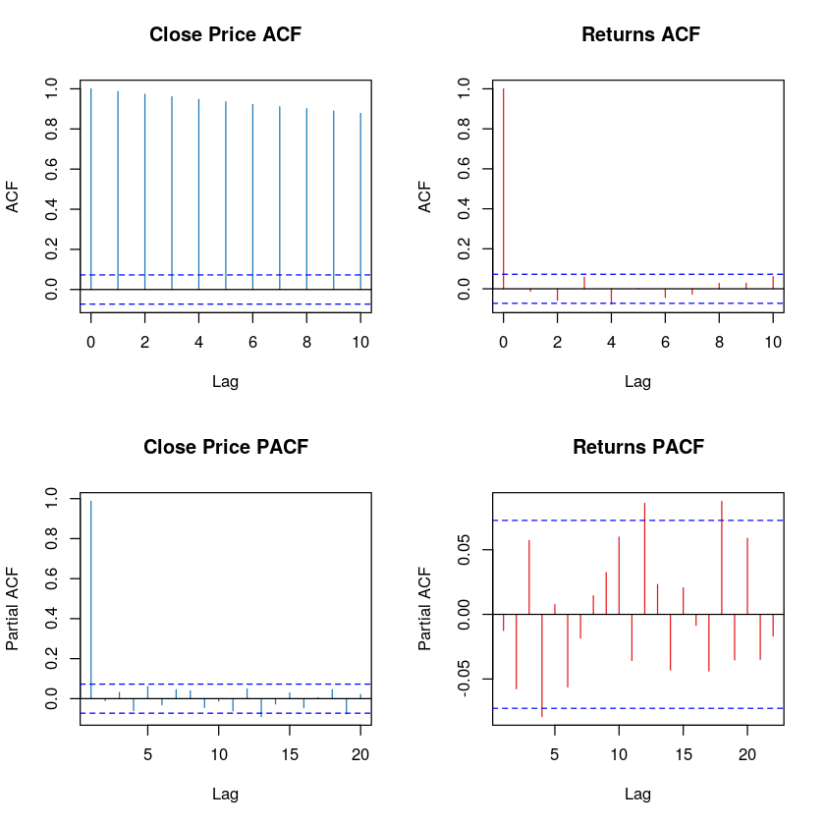

## 2.3.A. Conclusion

PACF crosses line at 4th lag of returns hence our AR value is 04. ACF does not crosses the line, hence MA: 0

Hence our model 1 is of type ARIMA (4,0,0)

## 2.4.A. Fitting model

We now pass the training set to model with the specified order.

## 2.5.A Method 1: Running Diagnostic checks on residuals: Visual Method

Now we derive the residuals from model 1 and plot diagnostic plot.

Figure 5: Model 1 ARIMA (4,0,0) residuals diagnostic checks.

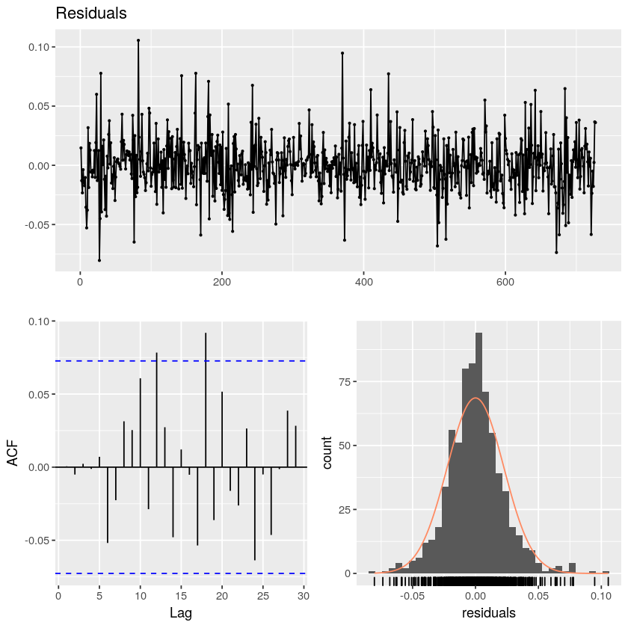

## 2.5.A Method 1: Result and Conclusion

Our residuals are normally distributed, with limits -0.5 and +0.5 and ACF plot of lagged values of residuals are not correlated for at least 8th lag. Also, residuals are stationary and thus we do not find any unaccounted correlation of lagged residuals in data.

## 2.5.A Method 2 Running Diagnostic checks on residuals: Ljung–Box Test

Ljung-Box test is used to find if the series has any autocorrelation:

H0: Series do not have Auto Correlation.

H1: Series have Auto Correlation.

On getting p value of 0.9876 we fail to reject our null hypothesis that residuals do not have autocorreation, hence we proceed to predict with the model.

***But we can also find the ARIMA model using a mathematical way using Auto ARIMA, so in next part we will derive another model and carry same diagnostic test on them.***

## Part B:

## 2.3.B. Finding AR and MA component: Software recommendation (Auto ARIMA)

Auto ARIMA suggest us to use (0,0,0) model

## 2.4.B. Fitting the model: Attempt 2 -> (2,0,3)

We save the residuals to run diagnostic checks for the next

## 2.5.B Method 1: Running Diagnostic checks on residuals: Visual Method??

Figure 6:Model 2 ARIMA (2,0,3) residuals diagnostic checks.

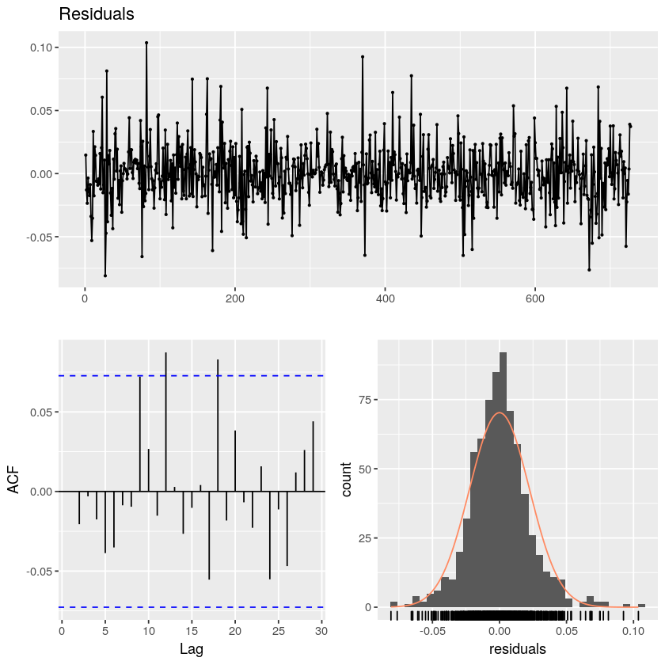

## 2.5.B Method 1: Result and Conclusion

Inspire of normality of residuals, our residuals have some auto correlation as can be seen from ACF plot, to verify mathematically we perform Ljung–Box Test.

## 2.5.B Method 2 Running Diagnostic checks on residuals: Ljung–Box Test

P value of 0.9572 suggest that we series do not have auto correlation hence we proceed to predict the with the model.

## 2.5.1 Adding fitted values of model_1 and model_2 to data frame

We need to plot and fitted and predicted values, so we start by adding fitted values of both models back to data frame as columns as seen below.

Table 4: Data frame with fitted values of Model 1 and Model 2

|  |  |  |  |  |
| --- | --- | --- | --- | --- |
| Date | Close | Returns | fit_1 | fit_2 |
| 42374 | 48.5 | 0.014538 | -0.00015 | -0.00012 |
| 42375 | 47.85 | -0.01349 | -0.00051 | -0.00054 |
| 42376 | 46.7 | -0.02433 | -0.00104 | -0.00082 |
| 42377 | 46.6 | -0.00214 | 0.001572 | 0.001402 |
| 42380 | 45.9 | -0.01514 | -0.00067 | -0.00107 |
| 42381 | 45.1 | -0.01758 | -0.00035 | -0.00016 |

## 2.6 Making Predictions from test set.

Since we will be plotting predicted values too, hence we append them back to our data frame. Our new data frame looks as following:

Table 5: Final Data frame with Predicted values.

|  |  |  |  |  |
| --- | --- | --- | --- | --- |
| Date | Close | Returns | fit_1 | fit_2 |
| 43448 | 39.65 | -0.01129 | -0.00099 | 0.001729 |
| 43451 | 39.95 | 0.007538 | -0.00058 | -0.0027 |
| 43452 | 41.15 | 0.029595 | -0.00141 | 0.001592 |
| 43453 | 41.9 | 0.018062 | -0.00299 | -0.00094 |
| 43454 | 44 | 0.048904 | -0.00012 | -0.00075 |
| 43455 | 42.9 | -0.02532 | -0.00012 | 0.001115 |

# 3.A Plotting Model 1: ARIMA (4,0,0)

Figure 7: ARIMA (4,0,0) Actual Returns vs Fitted and Predicted Returns.

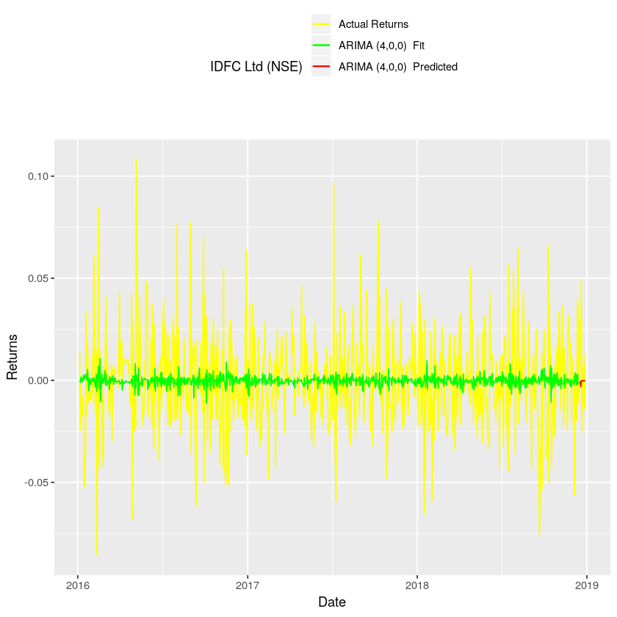

We notice that model 1: ARIMA (4,0,0) is very far away from predicting our stocks returns, it seems that most of the spikes are all unaccounted for in the model.

# 3.B Plotting Model 2: ARIMA (2,0,3)

Figure 8:ARIMA (2,0,3) Actual Returns vs Fitted and Predicted Returns.

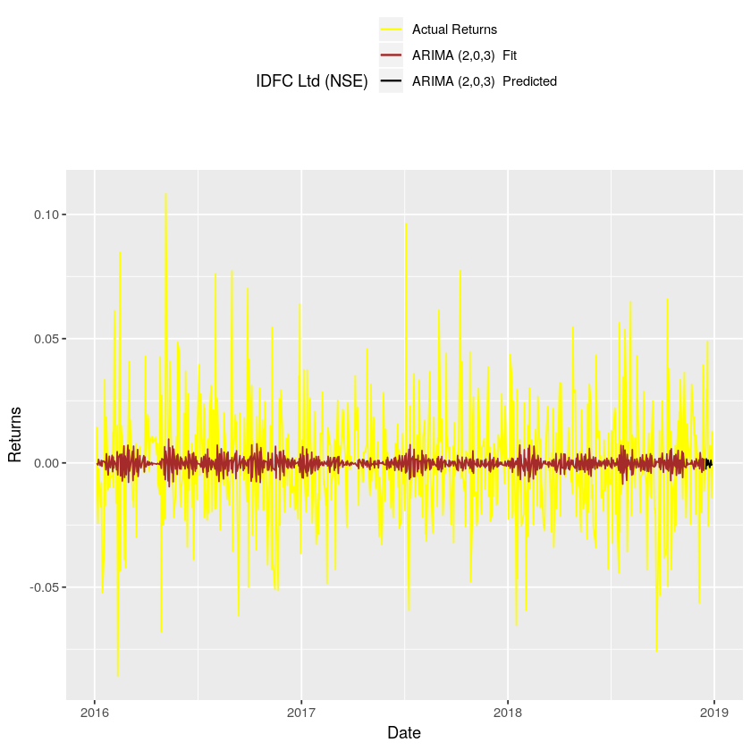

We notice that ARIMA(2,0,3) is very far away from predicting our stocks returns, it seems that most of the spikes are all unaccounted for in the model.

# 3. (A, B) Plot: Model 1 vs Model 2

Figure 9: ARIMA (4,0,0) vs ARIMA (2,0,3) Fitted and Predicted Returns.

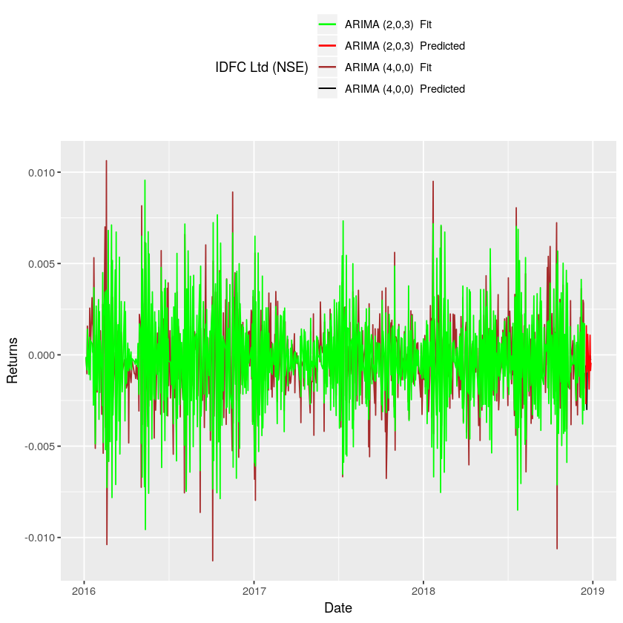

It seems that both model 1 ARIMA (4,0,0) and model 2 ARIMA(2,0,3) are almost same and have similar prediction.

# Finding Model Accuracy

From above plots we are confused as both models predict almost similar values as can be seen from the graph and both of this model are far away from predicting the model. So, we wanted to know the accuracy of the two model which will also tell the difference between them.

There are 4 methods available to find model accuracy:

## 4.1. MAE

$\frac{1}{n}\sum_{n}^{t=1}{}A_{t}−F_{t}∨$

Which we reject as they do not consider the effect of magnitude of data. And our MAE value will always be very small as day-to-day returns are very small.

This will always understate our model errors.

##### 4.2. RMSE

$\sqrt{\frac{\sum{{\left|A_{t}−F_{t}\right|}^{2}}}{n}}$

Which we reject as they do not consider the effect of magnitude of data. And our RMSE value will always be very small as day-to-day returns are very small.

This will always understate our model errors.

##### 4.3. MAPE

$\left\{\frac{1}{n}∑\frac{\left|A_{t}−F_{t}\right|}{\left|A_{t}\right|}\right\}x100$

We accept MAPE as it takes the percentage difference hence eliminating the scaling effect of MAE ad RMSE.

##### 4. MASE

$\frac{MAE}{MAE_{NaiveModel}}$

We also we compare our model with the NAIVE method, this tells us whether all our Hard work performing the ARMIA can be just be performed better by NAIVE method’s value greater than one will suggest that our ARIMA modeling was useless and vice versa.

## 4.1 Results: Accuracy by MAPE

ARIMA (4,0,0): 102.55"  
ARIMA (2,0,3): 106.24"

## 4.2 Results: Accuracy by MASE

ARIMA (4,0,0): 0.7

ARIMA (2,0,3): 0.71

# 5 Conclusion

From MAPE value we can conclude that error percentage of model is 102% hence the predictions are of no use if want to invest IDFC Ltd using our model to predict data. But, despite having 102% error, our model was better than NAIVE approach, as can be seen from MASE value less than 1.

Also, both of our model had different MAPE value producing a winner which was model 1 ARIMA (4,0,0) with MAPE value was 3.69% lower than MODEL 2 ARIMA (2,0,3). It seems we cannot trust Auto ARIMA or mathematical manner of detecting parameters. We argued in our report earlier that Visual methods are mutually exclusive, and hence should be not be ignored and here we have a concrete proof of it.

Since we argued that spikes of data were unaccounted for, hence we plot a Moving average of returns for 4 days and replot fitted and predicted values of both model.

Figure 10: Moving Average Returns vs ARIMA (4,0,0) & ARIMA (2,0,3) Fitted and Predicted Returns.

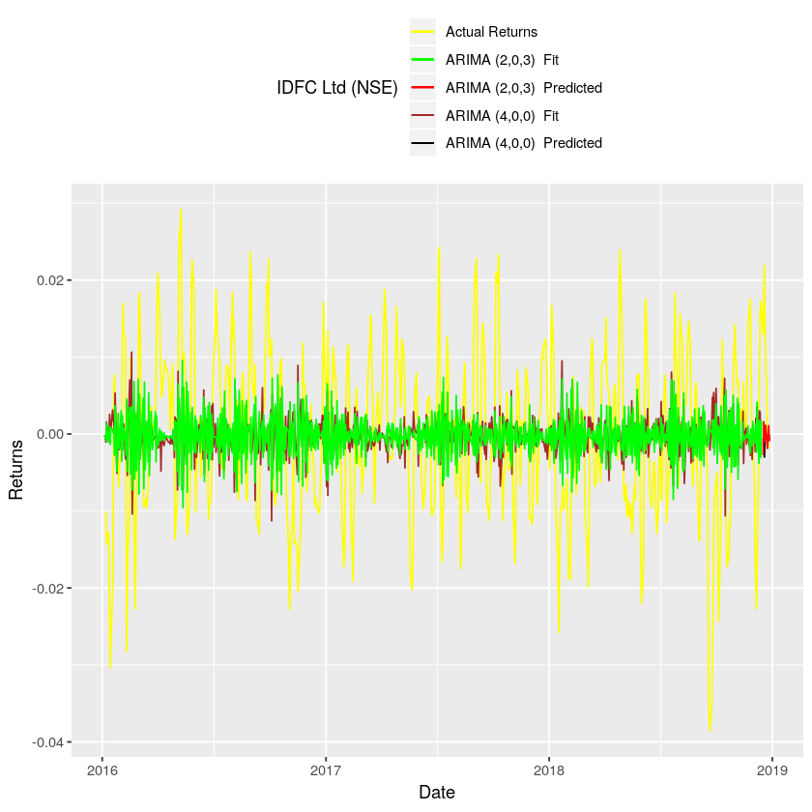

It Can be clearly noticed that our argument that spikes of data were unaccounted for can be clearly seen, as by taking moving average and removing skis in data, we notice that both the model is overlapping returns. Hence this model is weak in accounting the spikes in data.